**About Project**

Stock Market Analysis and Prediction is the project on technical analysis, visualization, and prediction using data provided by Google Finance ,Amazon, Apple,etc. By looking at data from the stock market, particularly some giant technology stocks and others. Used pandas to get stock information, visualized different aspects of it, and finally looked at a few ways of analyzing the risk of a stock, based on its previous performance history. Predicted future stock prices through a Monte Carlo method!

The purpose of this project is to comparatively analyze the effectiveness of prediction algorithms on stock market data and get general insight on this data through visualization to predict future stock behavior and value at risk for each stock. The project encompasses the concept of Data Mining and Statistics. This project makes heavy use of NumPy, Pandas, and Data Visualization Libraries.

**A. Analyzing stock data.**  
We need to provide data of a particular company, and its Monthly Sales / Profit report with Months High and Low points of its Stock.  
**B. Analyzing the factors.**  
We have to obtain the data in the same period for the following factors.  
1. Demand and Supply: We will obtain by the previous data entered.  
2. Corporate results: Companies declare their performance results and profit at the end of each quarter.  
3. Popularity: If any news about a company is about to come and is it bad or good.  
We have to analyze the variations in the stock value of the companies with respect to these factors using some data mining algorithms.

For example:

* We receive data from Quandl in this way

|  | **Open** | **High** | **Low** | **Close** | **Volume** | **Adj Close** |
| --- | --- | --- | --- | --- | --- | --- |
| **Date** |  |  |  |  |  |  |
| **2016-01-04** | 102.610001 | 105.370003 | 102.000000 | 105.349998 | 67649400 | 103.586180 |
| **2016-01-05** | 105.750000 | 105.849998 | 102.410004 | 102.709999 | 55791000 | 100.990380 |
| **2016-01-06** | 100.559998 | 102.370003 | 99.870003 | 100.699997 | 68457400 | 99.014030 |
| **2016-01-07** | 98.680000 | 100.129997 | 96.430000 | 96.449997 | 81094400 | 94.835186 |
| **2016-01-08** | 98.550003 | 99.110001 | 96.760002 | 96.959999 | 70798000 | 95.336649 |

* We make this data after operation to look something like this

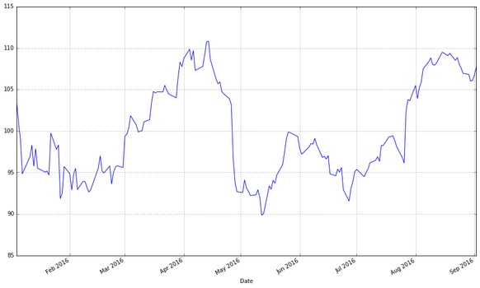

**Some important terminologies:**

* **ROLLING MEAN**

The moving average, which is another powerful tool, is the average of closing price for a specified time period and is plotted along with the price chart. It is also called the rolling average, rolling mean, or running average.  
  
Assume that you want to calculate 10 days’ moving average. For this, the first 10 days' closing price is added and divided by 10, and this value is plotted along with the closing price on the tenth day.  
  
On the eleventh day, you have to recalcula .. 

**ACTIVE TRADING**

Active trading is the  buying and selling of [securities](https://www.investopedia.com/terms/s/security.asp) with the intent of holding them for a short duration, usually no longer than one day. Active trading as an [investment strategy](https://www.investopedia.com/terms/i/investmentstrategy.asp) seeks to take advantage of short-term price movements with a focus on highly [liquid](https://www.investopedia.com/terms/l/liquidity.asp) markets like [stocks](https://www.investopedia.com/terms/s/stock.asp), [currencies](https://www.investopedia.com/terms/c/currency.asp), [options](https://www.investopedia.com/terms/o/option.asp), and [derivatives](https://www.investopedia.com/terms/d/derivative.asp). Active trading is considered one of the most [speculative](https://www.investopedia.com/terms/s/speculation.asp) trading strategies.

**PASSIVE TRADING**

passive traders are usually those who are interested in investing their money without the same kind of time commitment as active traders. They sometimes put their money into the hands of a trusted broker and then walk away.

**PRICE BAND**

A price band is a value-setting method in which a seller indicates an upper and lower cost limit, between which buyers are able to place bids. The price band's floor and cap provide guidance to the buyers. This type of auction pricing technique is often used with initial public offerings (IPOs).  
  
The bottom band is the lower limit and the top band is known as the upper limit. Determining the price band is a critical step in [book building](https://www.investopedia.com/terms/b/bookbuilding.asp), as it enables a firm to understand how much money investors are willing to pay for an ownership stake in the firm.

**SPY**

The **SPDR S&P 500 trust** is an [exchange-traded fund](https://en.wikipedia.org/wiki/Exchange-traded_fund) which trades on the NYSE Arca under the symbol ([NYSE Arca](https://en.wikipedia.org/wiki/NYSE_Arca): [SPY](https://www.nyse.com/quote/ARCX:SPY)). SPDR is an acronym for the Standard & Poor's Depositary Receipts, the former name of the ETF.